**Skill Development Program – Java & Spring Boot**

Pluralsight - <https://www.pluralsight.com/courses/spring-boot-fundamentals?clickid=Cj0KCQiAsaS7BhDPARIsAAX5cSCgvrhgFzv1lNIFkK-BVzbe7YdN-YOn8n7pyEvxCivxnI0flh-31EkaAmKjEALw_wcB&utm_source=google&utm_medium=paid-search&utm_campaign=upskilling-and-reskilling&utm_term=ssi-emea-dynamic&utm_content=free-trial&gad_source=1&gbraid=0AAAAADmVFQbVuMK7tOTdLMvu0BeByelHG&gclid=Cj0KCQiAsaS7BhDPARIsAAX5cSCgvrhgFzv1lNIFkK-BVzbe7YdN-YOn8n7pyEvxCivxnI0flh-31EkaAmKjEALw_wcB>

Udemy - <https://www.udemy.com/course/java-spring-boot-complete-course-bundle/?utm_source=adwords&utm_medium=udemyads&utm_campaign=Search_DSA_Beta_Prof_la.EN_cc.ROW-English&campaigntype=Search&portfolio=ROW-English&language=EN&product=Course&test=&audience=DSA&topic=&priority=Beta&utm_content=deal4584&utm_term=_._ag_162511579404_._ad_696197165421_._kw__._de_c_._dm__._pl__._ti_aud-2268488108799%3Adsa-1677053911088_._li_9077007_._pd__._&matchtype=&gad_source=1&gbraid=0AAAAADROdO1uO3dzz9mes8mdDojqZet8R&gclid=Cj0KCQiAsaS7BhDPARIsAAX5cSDYD47jiiJOBt4-mDRKD68H7Ze3fnC_uPmCrNMBEpWk-hyl9bgZbucaAkApEALw_wcB&couponCode=2021PM20>

**JAVA**

***Documentation***

Official : https://docs.oracle.com/javase/tutorial/getStarted/index.html

Click “Next” for browsing the pages in it.

For Easy understanding: <https://www.javatpoint.com/java-tutorial>

OR <https://dev.java/learn/> OR <https://www.tutorialspoint.com/java/index.htm>

**YouTube Playlists**

Telusko - <https://www.youtube.com/playlist?list=PLsyeobzWxl7pe_IiTfNyr55kwJPWbgxB5>

[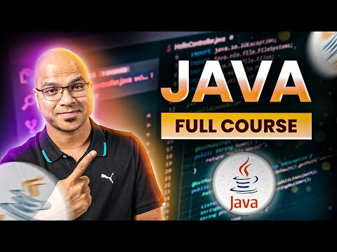](https://www.youtube.com/playlist?list=PLsyeobzWxl7pe_IiTfNyr55kwJPWbgxB5)

Apna Collage (Hindi) - <https://www.youtube.com/watch?v=UmnCZ7-9yDY>

[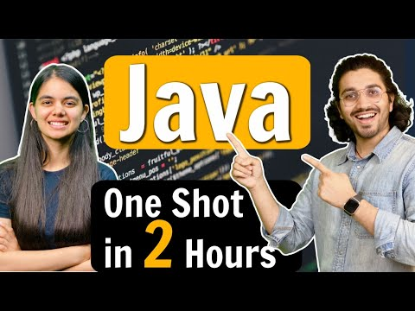](https://www.youtube.com/watch?v=UmnCZ7-9yDY)

Programming with Mosh - <https://www.youtube.com/watch?v=eIrMbAQSU34&t=106s>

[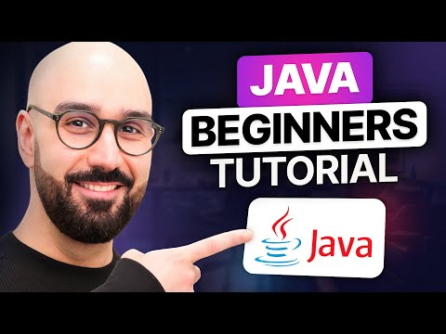](https://www.youtube.com/watch?v=eIrMbAQSU34&t=106s)

For **Master** IT

Freecodecamp.org - <https://www.youtube.com/watch?v=A74TOX803D0>

For Malayalam - <https://www.youtube.com/playlist?list=PLY-ecO2csVHeKaBI7lAM1jbIPU8K6fUxY>

[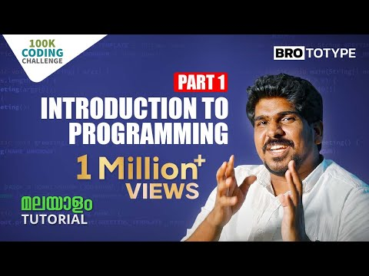](https://www.youtube.com/playlist?list=PLY-ecO2csVHeKaBI7lAM1jbIPU8K6fUxY)

**Java RoadMap**  
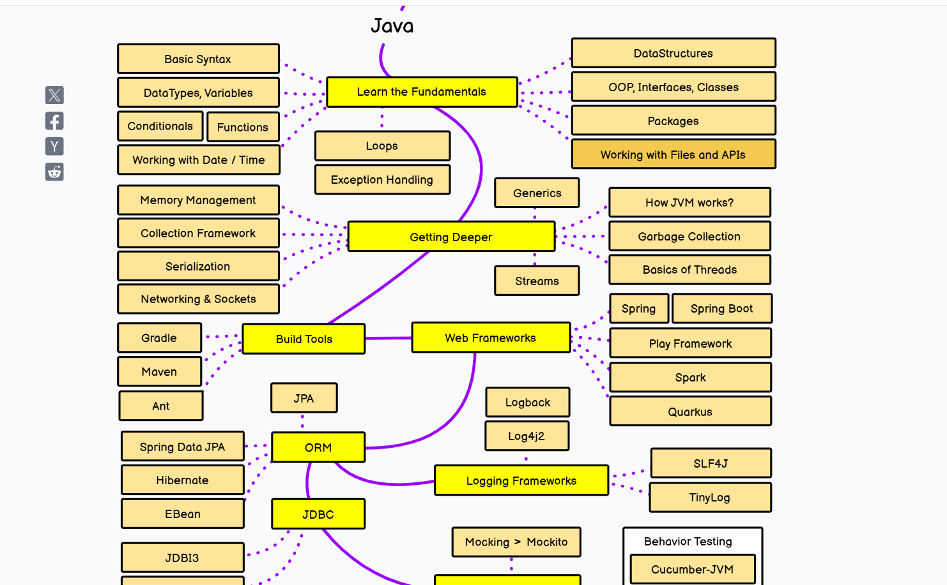

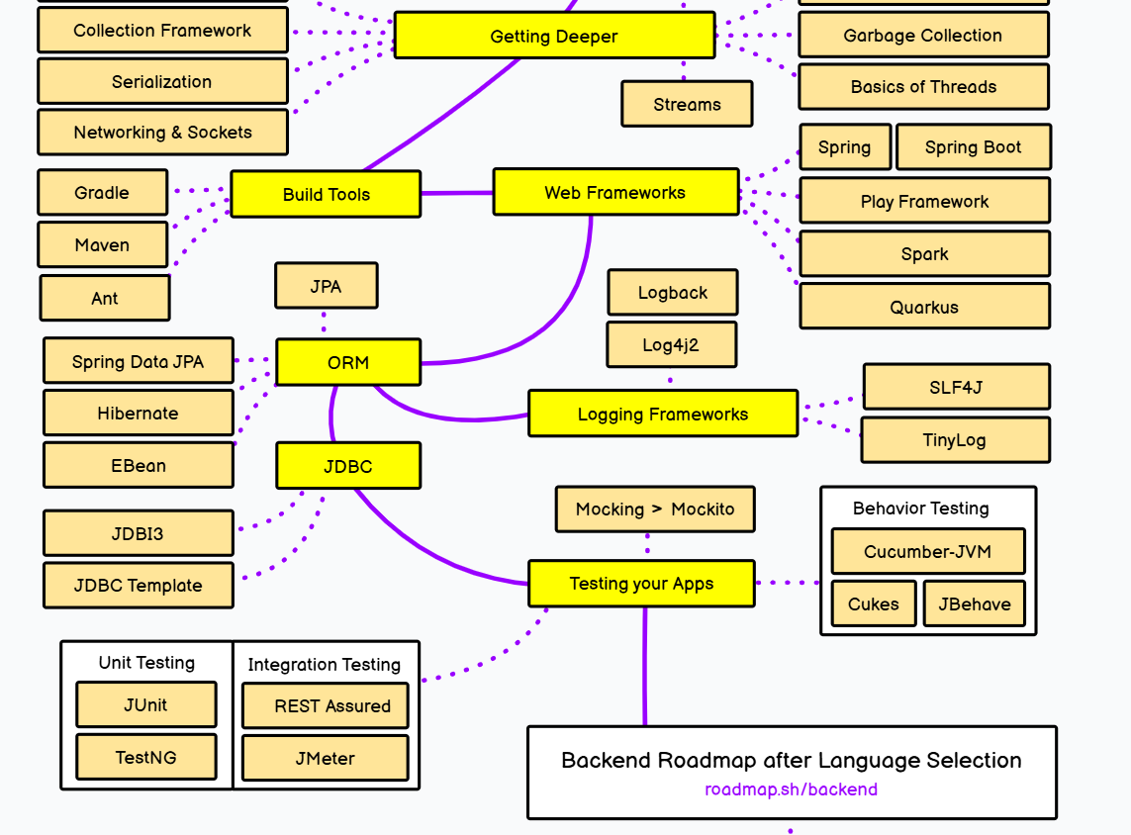

For Reference: https://roadmap.sh/java

**Back End Road Map**  
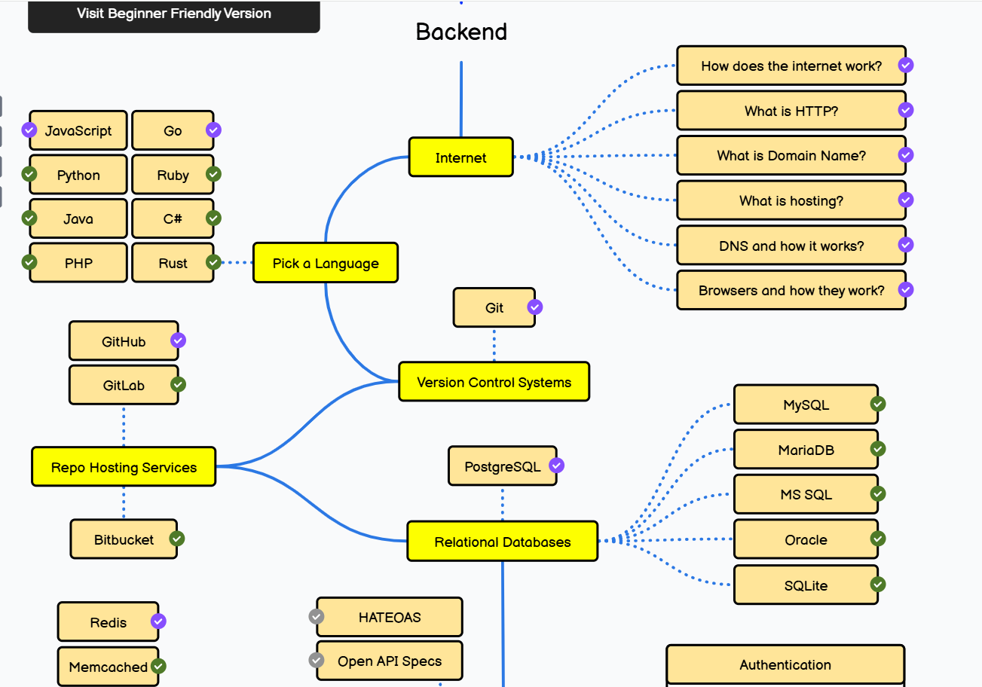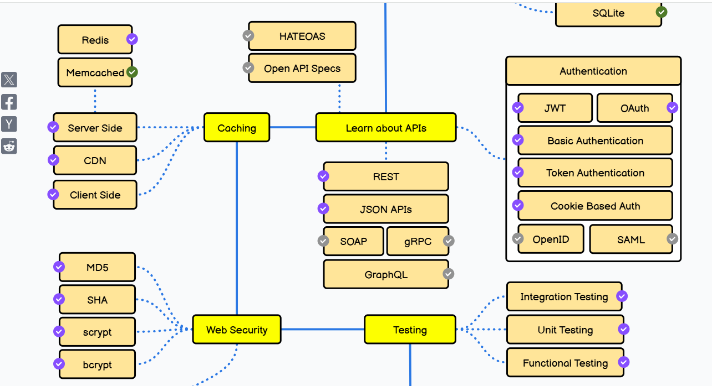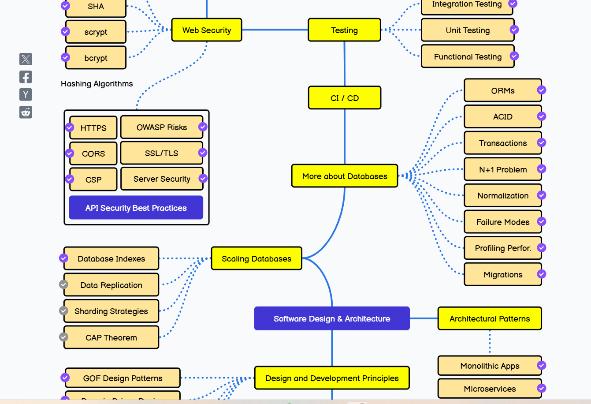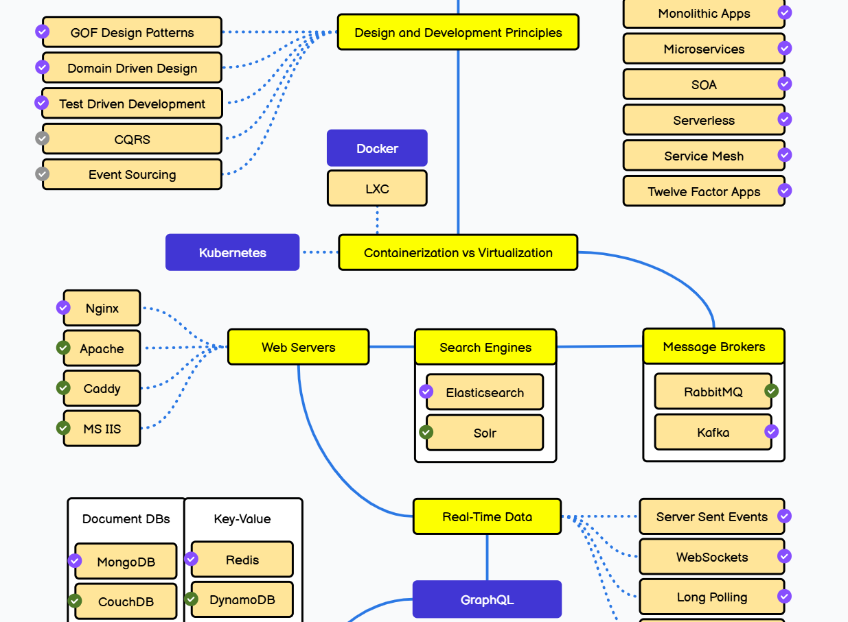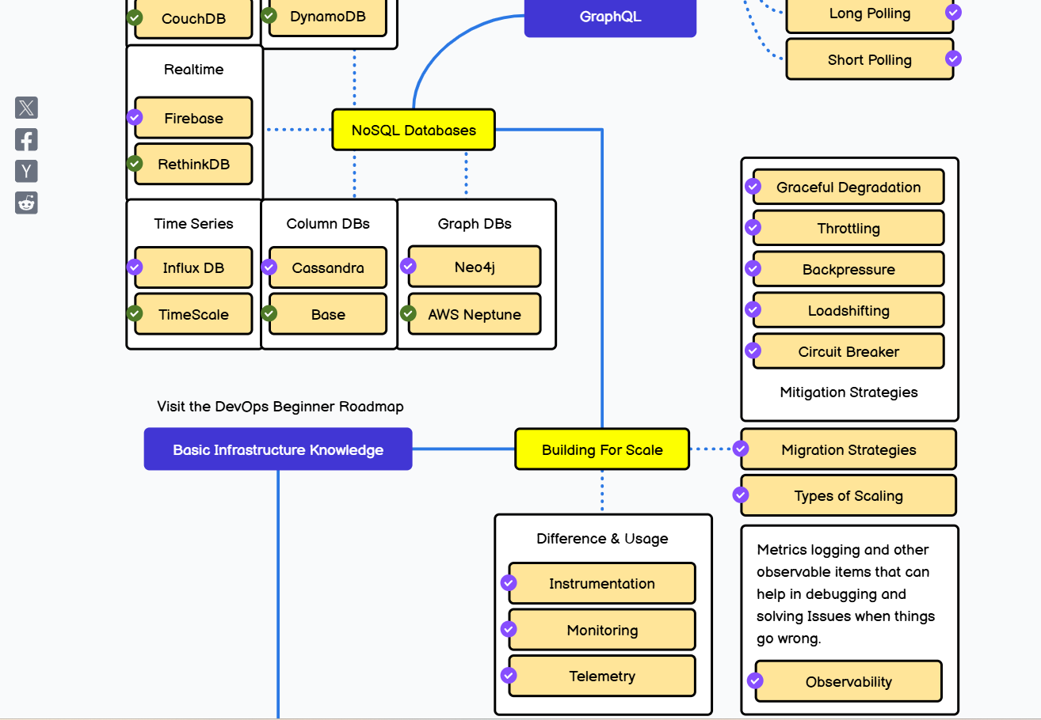

For Reference: <https://roadmap.sh/backend>

***Spring Boot***

**Documentation**

Official - <https://docs.spring.io/spring-boot/index.html>

GfG - <https://www.geeksforgeeks.org/spring-boot/>

JavaTpoint - <https://www.javatpoint.com/spring-boot-tutorial>

Better Code Reference

Baeldung - https://www.baeldung.com/spring-boot

YouTube :

Telusko - <https://www.youtube.com/playlist?list=PLsyeobzWxl7qbKoSgR5ub6jolI8-ocxCF>

[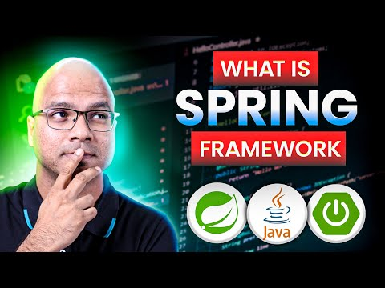](https://www.youtube.com/playlist?list=PLsyeobzWxl7qbKoSgR5ub6jolI8-ocxCF)

Java Guides - <https://www.youtube.com/playlist?list=PLGRDMO4rOGcOKUURLsVMKZbCZhZJNtEwW>

[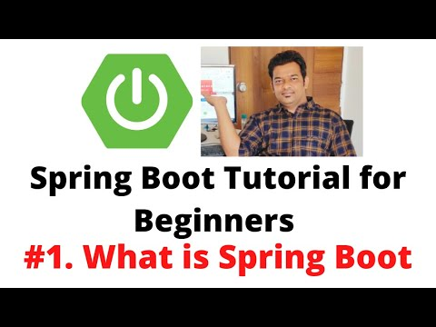](https://www.youtube.com/playlist?list=PLGRDMO4rOGcOKUURLsVMKZbCZhZJNtEwW)

Java Brains - <https://www.youtube.com/playlist?list=PLqq-6Pq4lTTbx8p2oCgcAQGQyqN8XeA1x>

[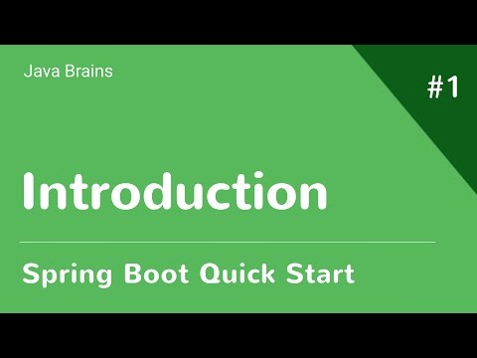](https://www.youtube.com/playlist?list=PLqq-6Pq4lTTbx8p2oCgcAQGQyqN8XeA1x)

Spring Security:

Dan Vega - <https://www.youtube.com/playlist?list=PLZV0a2jwt22s5NCKOwSmHVagoDW8nflaC>

[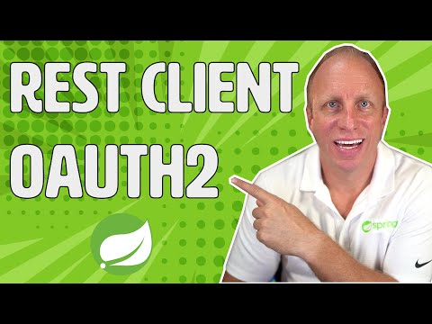](https://www.youtube.com/playlist?list=PLZV0a2jwt22s5NCKOwSmHVagoDW8nflaC)

<https://www.youtube.com/watch?v=UgX5lgv4uVM>

[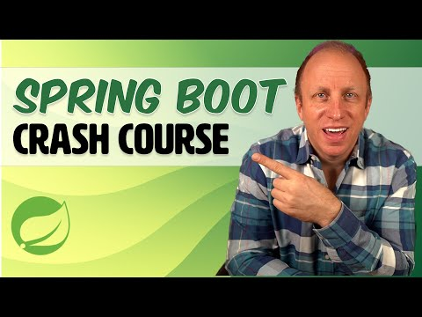](https://www.youtube.com/watch?v=UgX5lgv4uVM)

**Spring Boot RoadMap**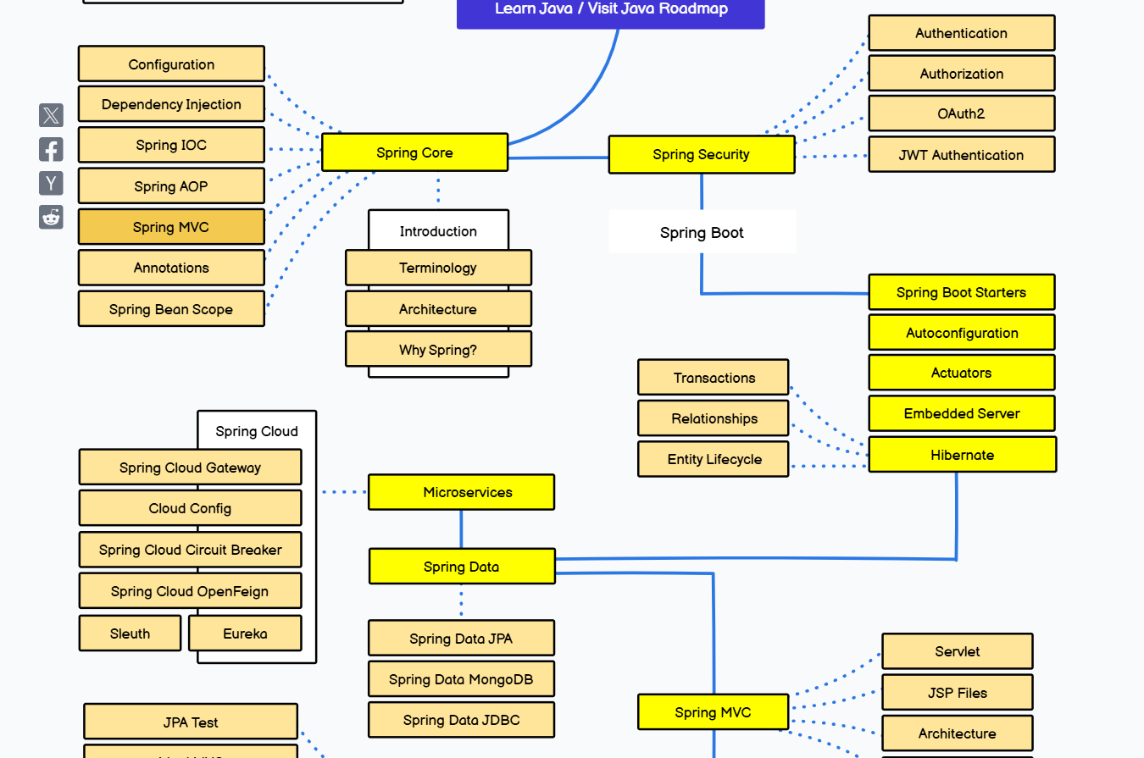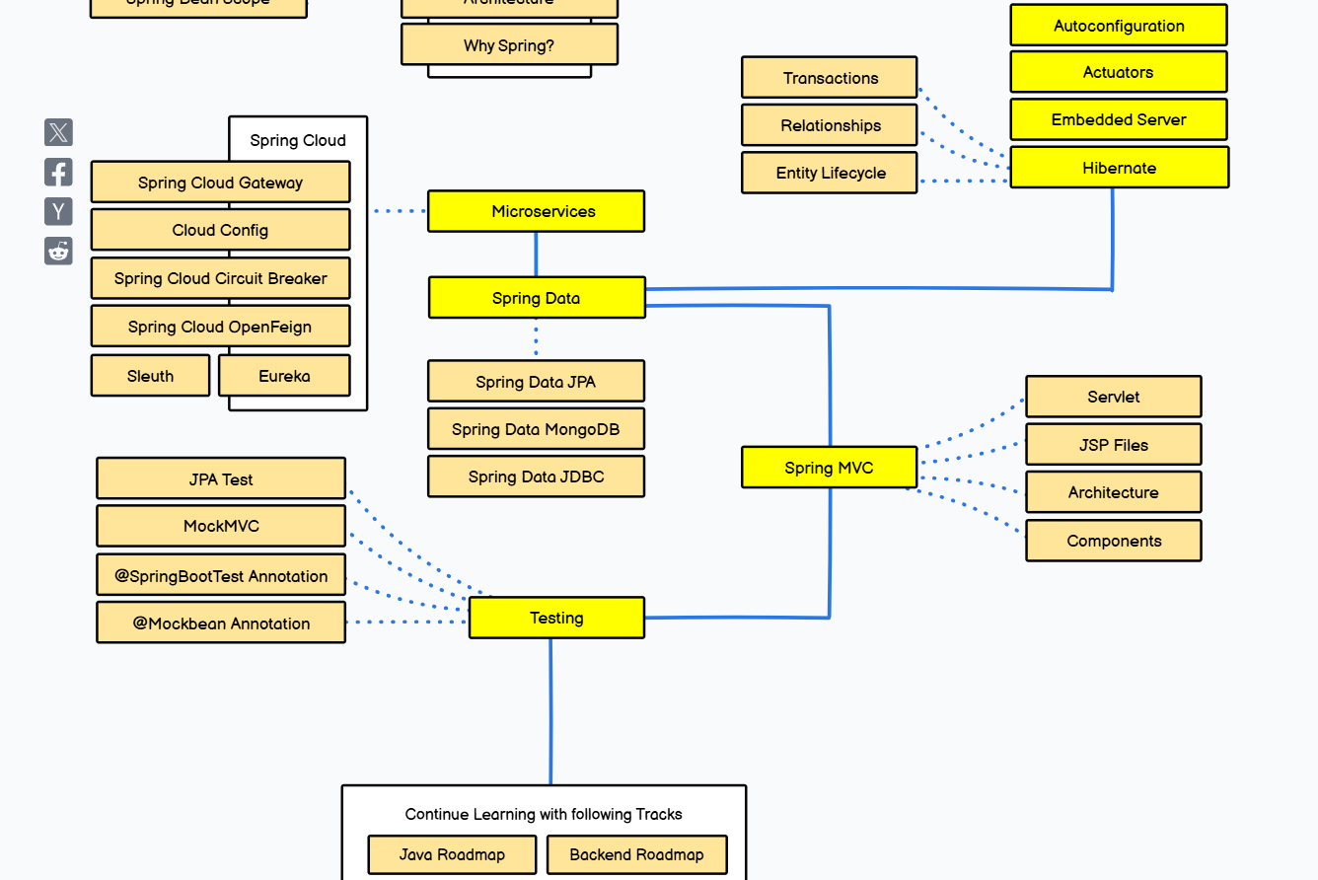For Reference: <https://roadmap.sh/spring-boot>